Building GUIs with Qt Designer and qtjs.
GUIs are useful to input data in some Octave simulations.This is very easy with Qt Designer and qtjs. Qt Designer lets you to build applications using drag and drop:
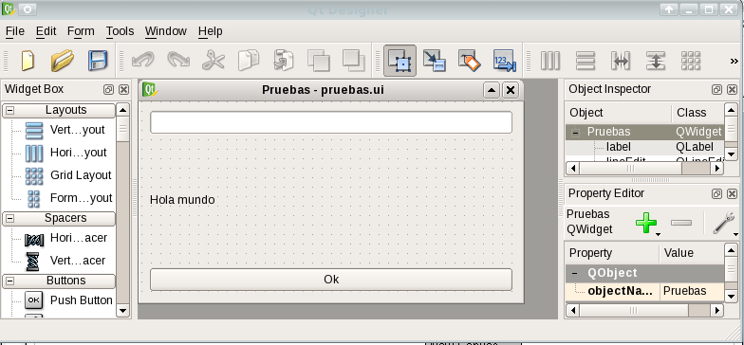
Draw your window, and them, use qtjs to connect widgets of your window with their slots. Qtjs uses Javascript. Don't worry you don't need high level in Javascript. Examples of this manual will teach you enough Javascript.

We are going to write a simple tool. This tool will plot “sombrero function”. We use “sombrero” function of Octave. “sombrero” function has one argument: Number of points in the net. This screenshot shows final result:

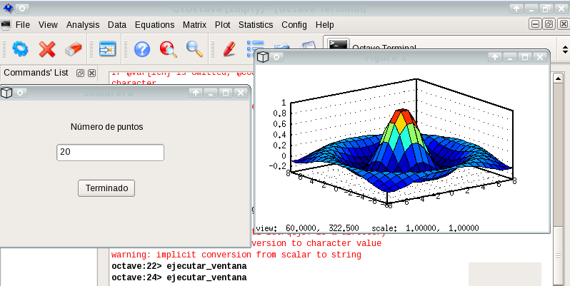

You will do this three steps:
- Plot your window with Qt Designer.
- Write events for your window with qtjs.
- Connect your application to Octave.

Step 1: Plot your window with Qt Designer.
You must open Qt Designer to plot yout window. First window ask us about type of window:
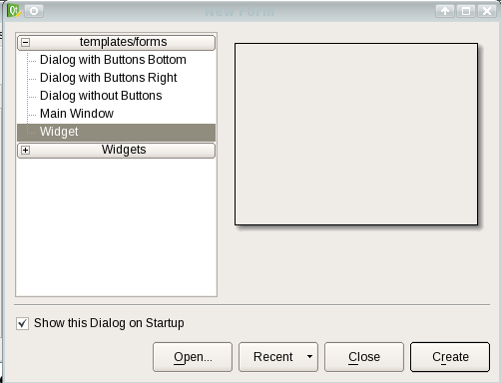
Select Widget, and them, press Create.
Now, you can drag and drop new widgets over Form:
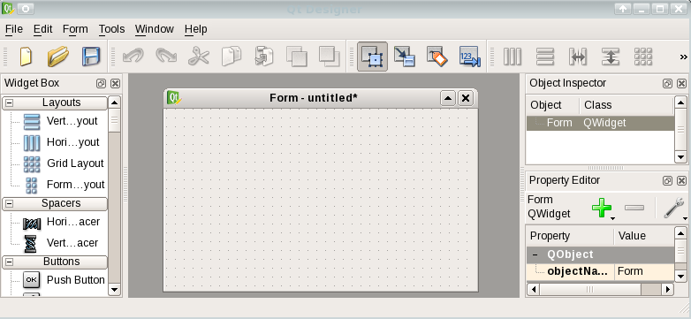
In left side of window there is a list called “Widget Box”. This list contains widgets. Widgets can be buttons, list or Web-browsers!! You can drag and drop widgets over your window.
Most important widgets are
- Push Button, this is a simple button
- Label.
- Line Edit, this is a box and you can write text in it.
We are going to drag a new label over our window. You can double click over text and change text. You can change position and size of "label" with your mouse:
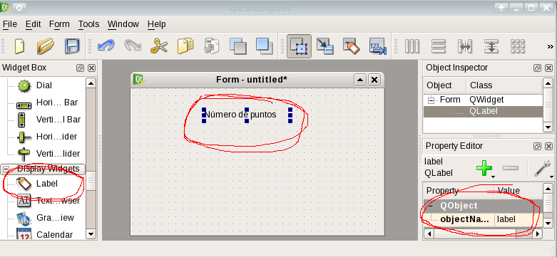
“Property Editor” show us properties of widget. The most important is "objectName", the name of widget. We will use this name later. Qt Designer sets "objectName" automatically, in this case is "label". You can change it.
We can add a new Push button and new Line edit:
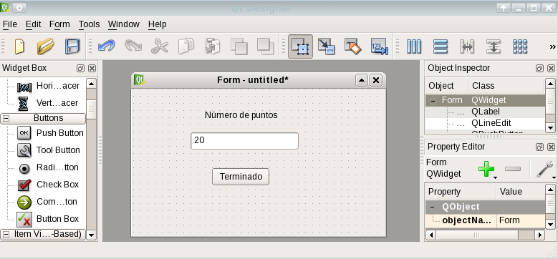
We can change properties of widgets. Qt Designer sets "objectName" and "pushButton" and "lineEdit" are set.
Finally we save our window as "sombrero.ui".
You can see your new window in "Form/Preview..." menu.

You can change name of your window. Change “windowTitle” property.

Step 2: Write events for your window with qtjs.
We have just written our window. We must create events for it. If you push "Start" button, our window must write an Octave commant. Then we write (in our text editor):

function start()
{
print("sombrero("+widget.lineEdit.text+")");
widget.close()
}

widget.pushButton.clicked.connect(start);

We must save it as “sombrero.js”.

If you know Javascript, you will not have any problem in this code. If you don't, I comment it:

function start()
{
print("sombrero("+widget.lineEdit.text+")");
widget.close()
}
This code is defining a new function "start". "widget.close()" close our window.

"widget" object is created by qtjs.

Our window has two widgets, lineEdit and pushButton. We must write "widget.lineEdit" or "widget.pushButton" in order to work with them.

"widget.lineEdit.text" is text inside line edit.

Line 'print(“sombrero(“+widget.lineEdit.text+”)”)' writes "sombrero(text in line edit)" in standar output.

Command 'print' of Javascript writes texts in standar output. Text strings must be in inverted commans and symbol + is used to link together strings and texts.

widget.pushButton.clicked.connect(start);

This line connects "start" function with click event of button.

We are going to check our tool. Write this in a terminal:

qtjs sombrero.ui sombrero.js

It will show a new window. If you press "start" button, command of Octave "sombrero" will be written in stardard output:
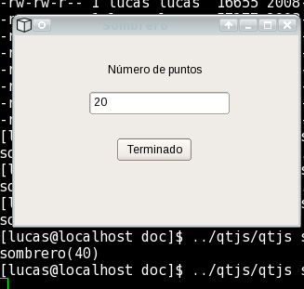

You can learn more Javascript in next examples. If you need more infomation, you can find lots of tutorials of Javascript in Internet.

Step 3: Connect your application to Octave.
Finally, we must connect out tool with Octave. You can choose between:
- Run this command:
octave --persist --eval `qtjs sombrero.ui sombrero.js`
- Use command "popen" of Octave. "popen" runs an applicacion and it can read or write data from the application:
function run_tool()
in=popen("qtjs sombrero.ui sombrero.js", "r");
while(!feof(in))
comando=fgets(in, 1024);
eval(comando);
endwhile
fclose(in);
endfunction

run_tool

Write this to run it:

octave --persist run_tool.m

It may not run. This is due to Octave path. You solve it using full paths. Example:
If files sombrero.ui and sombrero.js are in /home/user, you must write:

function run_tool()
in=popen("qtjs /home/user/sombrero.ui /home/user/sombrero.js", "r");
while(!feof(in))
comando=fgets(in, 1024);
eval(comando);
endwhile
fclose(in);
endfunction

run_tool

Other useful widgets.
We are going to study some useful widgets. You can find more data about them in:
http://www.trolltech.com/products

QPushButton.
This is a simple button.
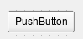

Properties.
- text: It is text inside button.
- icon: It is a picture inside the button.
- clicked.connect(function name): It runs "function name" when you push button.
You can change text or icon properties in Qt Designer.

QLabel.
It is a simple label.

Properties.
- text: It is text inside label.
You can change text property in Qt Designer.

QLineEdit.
QLineEdit is a one-line text editor.
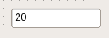

Properties.
- text: It is text inside label.
- returnPressed.connect(function name): It runs Javascript "function name" when you press return key.

Examples: sombrero2.ui and sombrero2.js, sombrero3.ui and sombrero3.js.

QSlider (horizontal or vertical).
It provides a vertical or horizontal slider
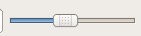

Properties.
- value: This property holds the slider's current value.
- minimum: This property holds the sliders's minimum value.
- maximum: This property holds the slider's maximum value.
- singleStep: This property holds the single step.
- pageStep: This property holds the page step.
- valueChanged.connect(function name): It runs Javascript "function name" when current value is changed.
Example: sombrero3.ui and sombrero3.js.

QComboBox.
It is a combined button and popup list.:
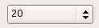

Properties.
- currentText: This property holds the text of the current item.
- currentIndex: This property holds the index of the current item in the combobox.
- activated.connect(function name): It runs Javascript "function name" when current value is changed..
Example: sombrero4.ui and sombrero4.js.

